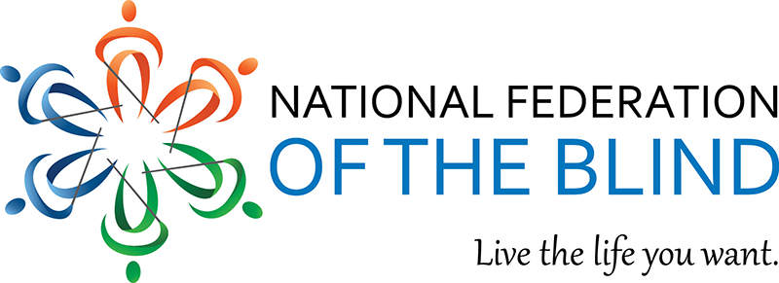

My Name is Theadora Williams and I am writing to you on behalf of the National Federation of the Blind of Greater Springfield Inc. chapter. (www.nfbmags.org). Your organization means so much to me and so many others in our community and our chapter. We are hoping that we may count on you for a sponsorship or a gift card. Founded in 1940, the National Federation of the Blind (NFB) is the largest organization run by and for people who are blind in the United States. The NFB is a non-profit organization dedicated to achieving full inclusion of the blind in society through advocacy and education. We do not believe that our blindness is the characteristic that defines who we are; therefore, we are very active in attempting to make positive changes to our community and show that we are and want to be productive citizens.

Some of the ways that we do this are by Helping Citizens that are losing vision to understand that blindness does not need to be a tragedy, awarding scholarships to deserving blind and visually impaired students to attend college as they work to become productive and independent citizens, by visiting our legislators both at their home and DC offices to lobby for initiatives important to blind people, and by holding an annual state convention where we try out the latest technology for the blind and learn about current issues concerning the blind community.

We would really appreciate your help in making these plans come to fruition. The best way you can help is by sponsoring us, or donating a gift card for a raffle prize. We love your products and would be so appreciative and impressed to have you be a part of our Eat for a Week and walk a thon fundraiser.

Our Taxpayer ID number: 046071412
If you have any questions or would like any additional information, please contact me. Thank you for your time and your consideration of this worthy cause.

Sincerely,

Theadora Williams

Theadora Williams,
President National Federation of the Blind of Greater Springfield Inc
413-733-5547 or 413-887-4376
nfbmags1948@gmail.com

