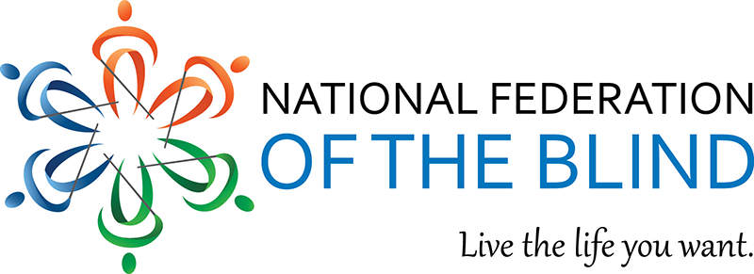
December 4, 2025

Dear Friend of visually impaired persons,

I am eager to invite you to the National Federation of the Blind (NFB) of Greater Springfield Inc. chapter Annual Walk on Saturday, June 20th, from 9:00 a.m. to 2:00 p.m., at the Van Horn Park, 910 Liberty Street Springfield, MA. Last year, thanks to contributions from supporters like you, we raised over $1,400 which enabled us to do the following:

- Train: help support the belle academy program for blind kids in the summer.
- Scholarships: We provided scholarships to assist two blind students in their pursuit of higher education.
- Advocacy: Members of the Springfield Chapter met with the Massachusetts Congressional delegation on Capitol Hill as part of the NFB Washington Seminar.
- Leadership Development: We supported and participated in seminars designed for emerging leaders and blind students.
- Communication: maintain and update our new chapter website monthly.

Please mark your calendar for Saturday, June 20th and join us for a morning filled with fun, friendship, and fundraising. We’ll be walking at the Van Horn Park located behind the chapter house.

You can support our local visually impaired in several ways: the annual walk, identifying sponsors, sponsoring a participant, or donating a gift card. If you are unable to attend but would still like to contribute, please make checks payable to NFB of greater Springfield Inc. and mail them to P.O. Box 3512 Springfield, MA 01101. Donations can also be made online via credit card or PayPal at nfbmags.org. Please indicated that your gift is for the NFB of GS Walk, remitted by December 1, 2026.

If you have any questions or would like any additional information, please call me, President and Walk Coordinator at 413-887-4376. Thank you for helping the visually impaired.

Sincerely,
Theadora Williams
Theadora Williams, President
NFB of Greater Springfield Inc. Chapter
P.O. Box 3515 Springfield, MA 01101
Taxpayer ID number: 046071412

