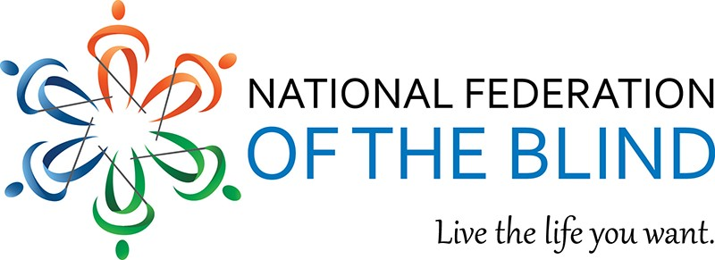

National Federation of the Blind
Of Greater Springfield Inc. Chapter
P.O. Box 3512
Springfield, MA 01101
Phone: 413 733-5547

Dear Friends:

It's that time of year again and we are seeking your help. The Greater Springfield Chapter of the National Federation of the Blind will hold our twenty-second annual Walk-A-Thon on Saturday May 18, 2024 at Van Horn Park, Springfield, MA. Walker registration will be held at the NFB Chapter House, 910 Liberty Street located adjacent to the park. Monies raised will support academic scholarships, as well as local NFB chapter projects.

Enclosed is our flyer describing the day's activities.Your donation of $100 or more will place your company's name on our tee shirts. We will also accept your generous donations for raffle prizes. We encourage companies to sponsor a walking team. Please fill out the form below and return it no later than April 17, 2024. Enclosed is a pre-addressed envelope for your convenience.

We look forward to your company’s participation.

Sincerely Yours,

Walk-A-Thon Committee, President Theadora Williams thadzisa@gmail.com

www.nfbmags.org

PLEASE RETURN BY April 17 2024.

Enclosed is a check for __$100, __$200, __$300, __$500, __$_____ Write in your pledge
(Please make checks payable to NFB of Greater Springfield Inc.)
(Please include company business card)
If company employees are participating on a walking team, please include the number of team members to assure adequate tee-shirt supply

Name ___________________________ Company_________________________

